1. What is LINQ Max Method in C#?

The LINQ Max() Method belongs to the category of Aggregate Operators. The LINQ Max Method in C# is used to return the largest numeric value from the collection on which it is applied.

1. Example to Understand LINQ Max Method in C#:

Let us understand the LINQ Max() method with Examples using C#. The following example returns the largest number from the collection using both query and method syntax. **The point that you need to remember is the Max Method is going to work with numeric values only**. In this case, the collection stores integer values, and hence we can apply the LINQ Max Method. We don’t have any operator called max in the Query Syntax. So here we need to use mixed syntax.

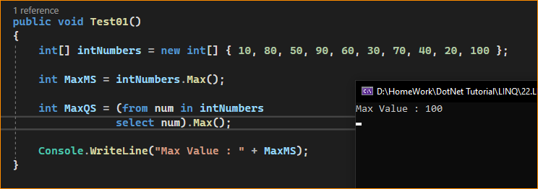

1. Example to Understand LINQ Max Method with Where Extension Method using C#

Let us see an example to Understand how we can use the LINQ Max Method along with the Where Extension Method in C# using both Method and Query Syntax.

* Now our requirement is to return the largest number from the collection where the number is less than 50. The following example code exactly does the same.

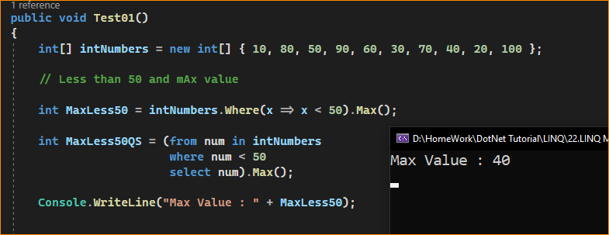

1. Example to Understand How to use LINQ Max Method with Predicate in C#

Let us see an example to Understand How to use LINQ Max Method with Predicate in C# using both Method and Query Syntax. Instead of using the Where Extension method to filter the data, we can also use the other overloaded version of the Max method which takes a Predicate as a parameter and using the predicate, we can write the logic to filter the data.

In the below example, within the Max Method, we are using a Predicate and we are providing the condition whether the number is less than 50 or not. If the number is less than 50, then we return that number else we return 0. The following example will return the largest number which is less than 50.

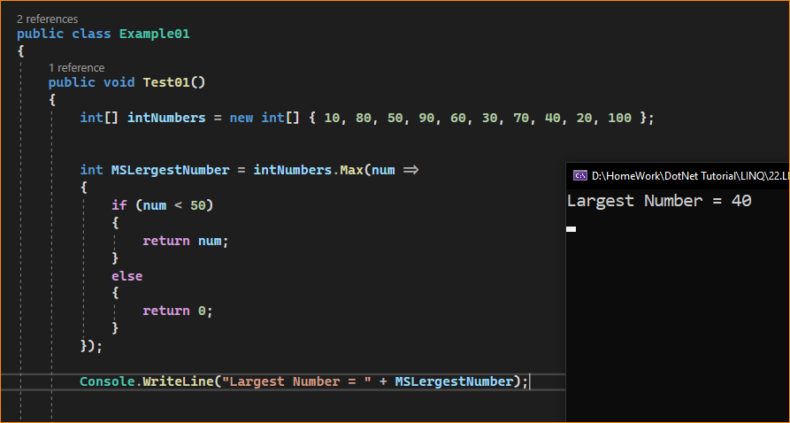

1. Example to Understand LINQ Max Method with Complex Type in C#:

Let us see an example to Understand How to use LINQ Max Method with Complex Data Type in C# using both Method and Query Syntax. We are going to work with the following Employee class. As you can see, it is a very simple class having four properties such as ID, Name, Salary, and Department. Here, we also created one method i.e. GetAllEmployees() which will return the list of all the employees and this is going to be our data source.

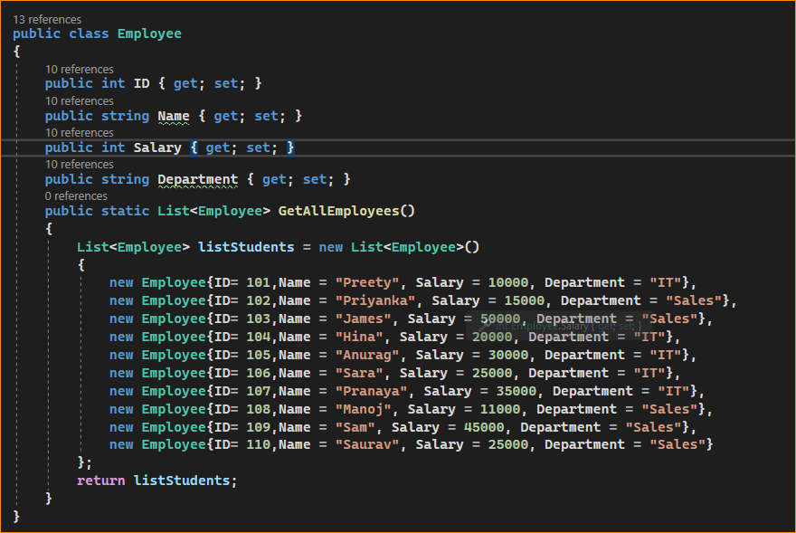

Now, our requirement is to return the highest salary among all the employees. The following example returns the highest salary among all the employees using the LINQ Max method with both Method and Query Syntax. Here, to the Max method, we are specifying the numeric Salary column using a lambda expression.

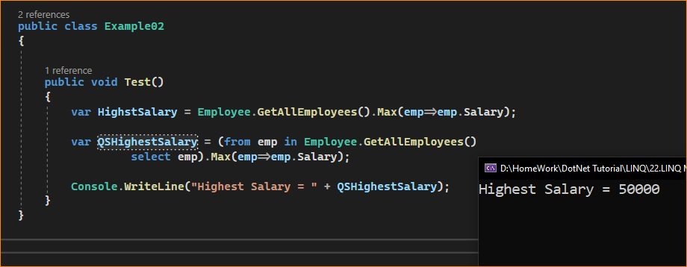

1. Example using Max and Where Extension Method in C#:

Let us see an example to Understand How to use both LINQ Max and Where Extension Methods with Complex Type using both Method and Query Syntax.

* Our requirement is to return the Highest Salary in the IT department. The following example exactly does the same. Using the Where Extension Method we are filtering the IT department employees and using the Max method we are specifying the Salary numeric column which will return the Highest Salary of the IT department.

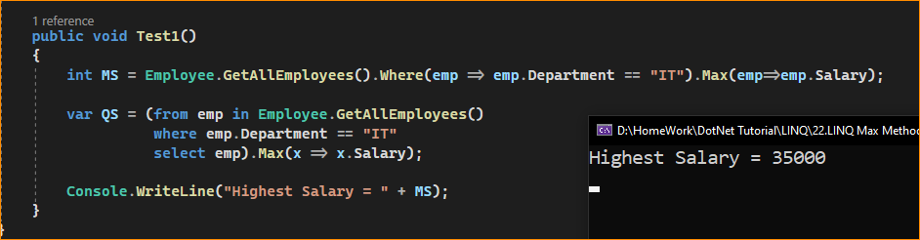

Let’s rewrite the previous example using the custom predicate. As you can see, within the Max method, we are checking the Department property value and if the Department is IT, we are returning the corresponding Salary else we are returning 0.

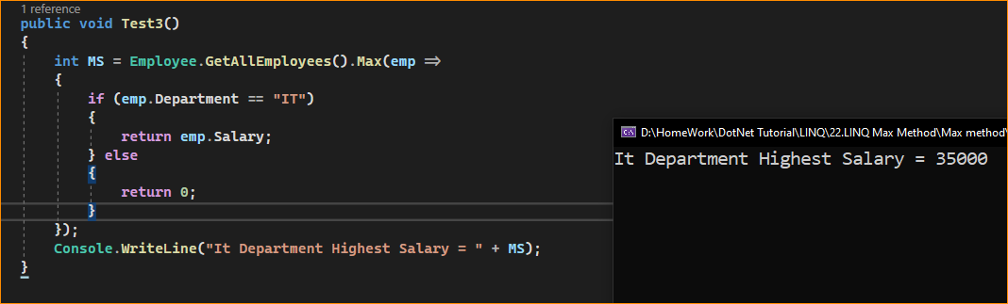

Let’s rewrite the previous example using the custom predicate. As you can see, within the Max method, we are checking the Department property value and if the Department value is It, we are returning the corresponding Salary else we are returning null.

